РЕАЛІЗАЦІЯ ПРОГРАМИ «СТИПЕНДІЇ ФУЛБРАЙТА»
вересень-жовтень 2017
4
Факультет іноземної філології МНУ ім. В.О. Сухомлинського
fif.mdu.edu.ua

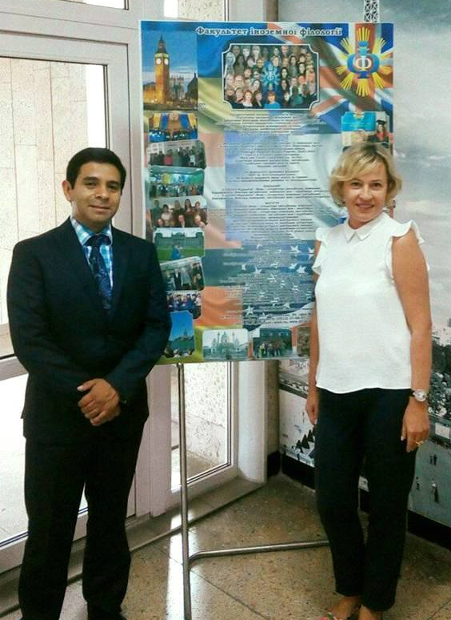
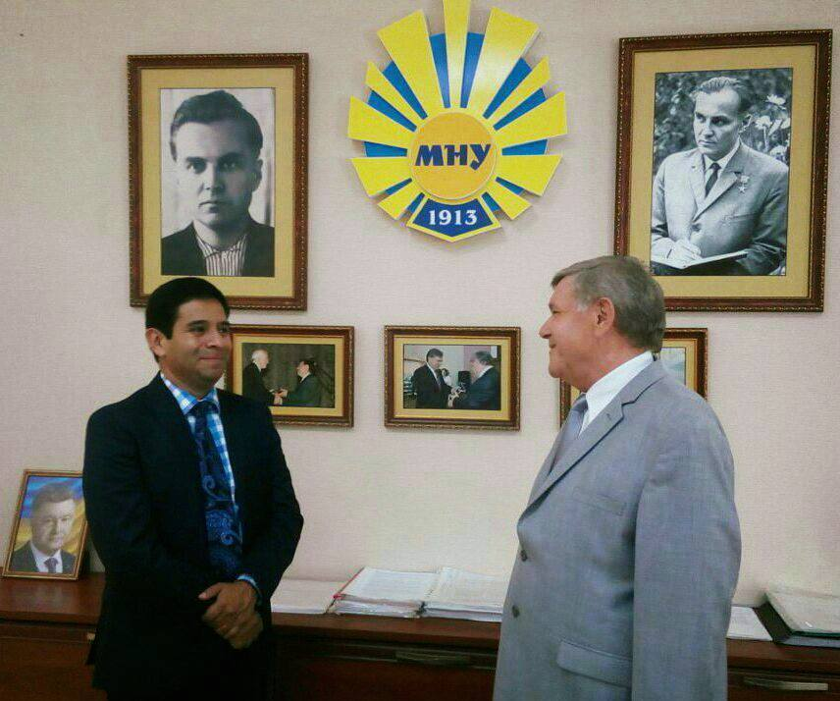
8 вересня 2017 року на факультеті іноземної філології МНУ імені В.О.Сухомлинського розпочалась реалізація програми “Стипендії Фулбрайта” в Україні на підставі гранту “Спеціаліст з викладання англійської мови, стипендіат програми Державного департаменту США” (English Language Fellow Program).
Стипендіат програми пан Хосе Луїс Переа-Хернандес (США) проводить

із Будаком В.Д., ректором МНУ ім. В.О. Сухомлинського

практичні заняття з англійської мови для студентів II, III курсів «English for Communication Course», надання консультацій з методики викладання англійської мови для викладачів та проведення наукових досліджень протягом 2017-2018н.р.

із Мороз Т.О., деканом факультету іноземної філології
Окрім того, факультет іноземної філології запрошує магістрантів, учителів та викладачів англійської мови до участі у програмі професійного розвитку з методики викладання англійської мови «American English Webinar Series 7». Розклад і тематика вебінарів:

1 | 04.10.2017 | 14.40-16.20 | 01.513 | Empowering Your Students with Media Literacy
2 | 18.10.2017 | 14.40-16.20 | 01.513 | Presenting Ideas through Digital Storytelling in the English Classroom
3 | 01.11.2017 | 14.40-16.20 | 01.513 | Understanding Documentation and Draft Writing for Teachers
4 | 15.11.2017 | 14.40-16.20 | 01.513 | Cross-cultural Competence in Business English
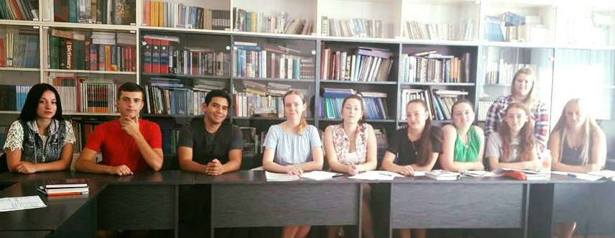
зі студентами 346-ІІ групи на занятті з курсу «English for Communication»

