Further readings:
- Read the article from TIME magazine written by Paul Gray in 1999. Before reading the text, fill out the first 2 columns of the chart. When you have read the article, complete the 3rd column.

What I know about Johann Gutenberg | What I would like to learn about Johann Gutenberg | What I learned about Johann Gutenberg

15th CENTURY: JOHANN GUTENBERG (c. 1395-1468)
The French peasant girl who rallied her country's dispirited troops against the occupying English forces; the Turkish ruler who conquered Constantinople and enlarged what would become the millennium's most durable empire; the Italian navigator who sailed the ocean blue in 1492. Joan of Arc, Sultan Mehmet II and Christopher Columbus indisputably made lasting history. But it was one of their 15th century contemporaries who created a revolutionary way to spread not only their names and deeds but the sum total of human knowledge around the globe.
Johann Gutenberg was born of well-to-do parents in the Archbishopric of Mainz, Germany. Details of his life, early as well as late, are sketchy, but he apparently trained as a goldsmith and/or gem cutter and then became a partner in a printing shop in Strasbourg.
When Gutenberg entered it, printing was a slow and laborious business. Each new page required the creation of a new printing form, usually an incised block of wood. He began looking for ways to make metal casts of the individual letters of the alphabet. The advantages of such a method were obvious, or must have been to Gutenberg. Equipped with a sufficient supply of metal letters, a printer could use and reuse them in any order required, running off not just handbills and brief documents but a theoretically infinite number of individual pages. There were technical obstacles to overcome, including the discovery of an alloy that would melt at low temperatures, so that it could be poured into letter molds, and of an ink that would crisply transfer impressions from metal to paper. And what force would be employed to make these impressions? Gutenberg hit upon the idea of adapting a wine press for new uses.
By the time he was back in Mainz in 1448, Gutenberg had ironed out enough of these problems to persuade Johann Fust, a goldsmith and lawyer, to invest heavily in his new printing shop. Exactly what happened behind Gutenberg's closed doors during the next few years remains unknown. But in 1455 visitors to the Frankfurt Trade Fair reported having seen sections of a Latin Bible with two columns of 42 lines each. The completed book appeared about a year later; it did not bear its printer's name, but it eventually became known as the Gutenberg Bible.
It was a revelation, at least to Western eyes: multiple copies of an entire volume produced by mechanical means. True, printing from movable type had been performed in Asia, but thousands of ideograms made the widespread use of the technique impractical. Gutenberg, who apparently knew nothing of the Asian innovations, was blessed not only with an inventive mind but also with a phonetic alphabet and its manageable cast of characters. Movable type was set to change the world. Presses adapted to print from movable type rapidly spread across Europe. By 1500 an estimated 30,000 titles had been published.
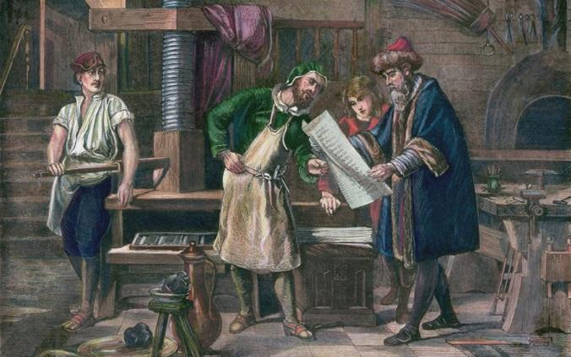
And that was only the beginning of a tide of print that has been rising ever since. We can hardly imagine a world without an abundance of printed matter, and thus we take for granted an invention that produced astonishing consequences. Early printed books tended to resemble, in appearance as well as content, the hand-copied manuscripts they were replacing. Before print, the ability to read was useful mainly to the elite and the trained scribes who handled their affairs. Affordable books made literacy a crucial skill and an unprecedented means of social advancement to those who acquired it. Established hierarchies began to crumble. Books were the world's first mass-produced items. But most important of all, printing proved to be the greatest extension of human consciousness ever created. It isn't over: the 500-year-old information revolution continues on the internet. And thanks to a German printer who wanted a more efficient way to do business, you can look that up.
(picture source: https://www.britannica.com/biography/Johannes-Gutenberg)

