MISLEADING INFORMATION AND POST-TRUTH

Content:
-learn the key features of false information and types of fake messages;
- apply methods of verification and refutation of unreliable information.
Language:
-learn basic terms and notions of fact-checking;
- improve their reading and speaking skills;
- improve their presentation skills.
Critical thinking:
- analyze the sources of fakes in media;
- personalize experience on informational issues;
- reflect on the personal progress.

PART 1. ACTIVATING PRIOR KNOWLEDGE

Ex. 1. Look at the word cloud. What terms are familiar and what terms are new? Can you give the definition of any of these terms? | 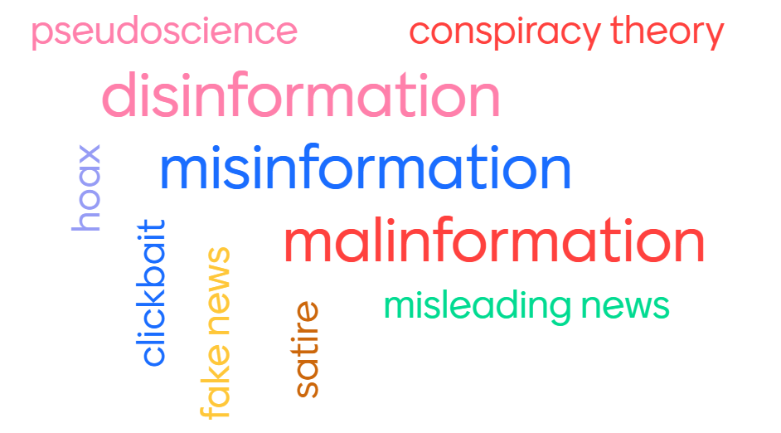

Ex. 2a. Work in groups. Match the words with their definitions.

1. Misinformation | a) Deliberate publication of private information for personal or corporate rather than public interest, such as revenge porn. Deliberate change of context, date or time of genuine content
2. Disinformation | b) Unintentional mistakes such as innacturate photo captions, dates, statistics, translations, or when satire is taken seriously.
3. Malinformation | c) Fabricated or deliberately manipulated audio/visual content. Intentionally created conspiracy theories or rumors.

Ex. 2b. Fill in the table below, write plus or minus accordingly.

 | Misinformation | Disinformation | Malinformation
Intention to harm
Truthfulness

Ex. 2c. Watch the video and check your understanding of the terms “mis/ dis/ malinformation”. What did you learn from this video?  https://www.youtube.com/watch?v=Vg3s6mQq3C0 | 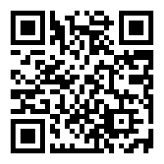

PART 2. PROVIDING AND ENCOURAGING OUTPUT

Ex. …. Work in groups. Read the article in the chart below and put the paragraphs in the correct order.

WHO says Covid misinformation

is a major factor driving pandemic around the world
Rich Mendez

PUBLISHED TUE, AUG 24 20213:38 PM EDTUPDATED TUE, AUG 24 20217:22 PM EDT

№ | Paragraph
… | A top World Health Organization official said on Tuesday that misinformation about Covid-19 and vaccines is keeping people from getting the shots, driving an increase in cases around the world.  “In the last four weeks or so, the amount of misinformation that is out there seems to be getting worse, and I think that’s really confusing for the general public,” Maria Van Kerkhove, the WHO’s technical lead on Covid, said during a Q&A livestreamed on the organization’s social media channels.  Misinformation has become another risk factor that is “really allowing the virus to thrive,” she said.
… | Public health leaders have blamed conspiracy theories and misinformation for growing distrust of the vaccines around the world — so much so that in July U.S. Surgeon General Vivek Murthy declared Covid misinformation a “serious public threat.”  Misinformation has become a growing problem in the outbreak, fueling vaccine hesitancy among a wary public, health officials say. They hope that the Food and Drug Administration’s formal approval of Pfizer’s Covid vaccine, which was announced Monday, will help push some people who have been on the fence about getting immunized to get the shots.
… | Three in 10 unvaccinated Americans said they would be more likely to get the vaccine once it is FDA-approved, according to a Kaiser Family Foundation survey conducted July 15-27. Some medical experts worry that some unvaccinated Americans used the lack of full FDA approval as a credible explanation for their hesitancy and will now look for other reasons to refuse to get the vaccine.  Most unvaccinated Americans think the Covid vaccines are more of a threat to their health than contracting the virus itself, according to Kaiser’s data. Americans least likely to receive a Covid-19 vaccine are mostly white, Republican and less likely to have a college degree, according to Kaiser’s data.
… | Dr. Peter Marks, director of the FDA’s Center for Biologics Evaluation and Research, said misinformation about the vaccine is “one of the biggest challenges that we still face in getting the public vaccinated.”  “We’ve heard false claims that the Covid-19 vaccine causes infertility, contains microchips and causes Covid-19,” Marks said. “And worse, we’ve heard false claims that thousands of people have died from the vaccine. Let me be clear: These claims are simply not true.”  Misinformation about alternative treatments for Covid-19 has gone so far that the FDA and the Mississippi State Health Department put out advisories over the weekend to warn Americans not to ingest animal de-wormer Ivermectin.
… | The director of the WHO’s Latin America branch, the Pan American Health Organization, made a personal appeal to residents of Caribbean countries to “wake up” from the slumber of misinformation spreading throughout the islands and get vaccinated.  Misinformation has plagued public school board meetings across the country as school districts weigh mask and vaccine mandates for children and staff returning for the upcoming school year. Parents and community residents have shown up to public school board meetings to lambast education and public health officials for considering mask mandates, and videos of residents citing unproven and false claims about Covid and vaccines have gone viral on social media.
… | Vaccination could help us get Covid under control by the spring, according to the chief medical advisor to the president, Dr. Anthony Fauci.  “I would like to appeal to the people in the country who are not vaccinated to realize that we have the capability among ourselves to essentially cut down the time frame to getting to the end of this pandemic,” Fauci said during a press briefing Tuesday. “Get vaccinated and the time frame will be truncated dramatically.”

Ex. …. Check the correct order of the paragraphs following the link: https://www.cnbc.com/2021/08/24/who-says-covid-misinformation-is-a-major-factor-driving-pandemic-around-the-world.html.
Ex. …. Think: Which types of false information, you have discovered in Ex. 2 (mis-, dis-, malinformation), we observe in the article?
Ex. …. Work in pairs. Say whether the key point statements are True or False. For the false statements give the true information. Compare the results with the rest of the class.

WHO official Maria Van Kerkhove said Tuesday that misinformation about Covid and vaccines appears to have gotten better and is encouraging people to get the shots, driving an decrease in cases.

In July, U.S. Surgeon General Vivek Murthy declared Covid misinformation a “serious public threat.”

Most vaccinated Americans think the Covid vaccines are more of a threat to their health than contracting the virus itself, according to Kaiser Family Foundation data.

1. F, 2. T, 3. F.

Ex. …. Brainstorm the situation with the vaccination campaign in Ukraine. Do we deal with the same types of misinformation? Why? Why not? Who benefits from it? What can be done about it?
Ex. …. Discuss the question: Can celebrities and famous bloggers influence the situation with misinformation concerning Covid 19 vaccination?

Ex. …. Work in groups. Watch a video “TikTok stars address vaccine hesitancy, misinformation” (https://www.youtube.com/watch?v=Bz4XIa0Lun0) and discuss the questions:

Will such actions be fruitful in Ukraine? Why? Why not?

Can any celebrity influence your personal attitude towards vaccination? Why? Why not?

Do you trust famous people or doctors more? Why?

PART 3. READING

Ex. …. Work in groups of three. Discuss the questions: What is done to avoid misinformation on popular media platforms? Is that enough? What else can be done?

Ex. … a. Read an article titled “How does YouTube combat misinformation?” and fill in the first 2 columns of the chart as in the example.

How does YouTube combat misinformation?
We address misinformation on our platform with a range of tools: removing content that violates our policies, raising up authoritative sources for news and information, and reducing recommendations of borderline content and harmful misinformation.

What policies exist to fight misinformation on YouTube?
Several policies in our Community Guidelines are directly applicable to misinformation.
The COVID-19 Medical Misinformation policy doesn't allow content that spreads medical misinformation that contradicts local health authorities’ or the World Health Organization’s (WHO) medical information about COVID-19.
Our guidelines against deceptive practices include tough policies against users that misrepresent themselves or who engage in other deceptive practices. This includes deceptive use of manipulated media (e.g. “deep fakes”) which may pose serious risks of harm. We also work to protect elections from attacks and interference, including focusing on combating political influence operations.
We also have a policy against impersonation. Accounts seeking to spread misinformation by misrepresenting who they are via impersonation are clearly against our policies and will be removed.
And finally, our hate speech policy prohibits content that denies well documented, major violent events took place.
(Adapted from https://www.youtube.com/howyoutubeworks/our-commitments/fighting-misinformation/)

Tools to combat misinformation/Type of media platform | You Tube | Twitter | Face book | … | …
1. Removing content that violates its policies | +

Ex. … b. Continue working in the groups of three. Use google search to fill in other columns of the chart. Compare and discuss the results with the rest of the class. Think what other tools can/should be used by the media platforms administrations to combat misinformation.

Ex. …. Work in pairs. Think of the cases of misinformation, which you recently dealt with in the real life. Discuss the consequences.

Ex. …. Work in small groups. Watch a video “Argonne News Brief: 'Abe' – A System for Combating Misinformation” (https://www.youtube.com/watch?v=SuzNOIzCSlI&t=57s). Prepare a presentation of a similar invented system to help combat misinformation in Ukraine. Discuss its benefits and possible consequences of its usage.

PART 4. GUIDING TO MORE CALP

Ex. . Read the text and discuss why post-truth society is a challenge to democracy.

Adapted from “Misinformation, Disinformation, Malinformation: Causes, Trends, and Their Influence on Democracy”, LEJLA TURCILO AND MLADEN OBRENOVIC,
A Publication of Heinrich Böll Foundation, August 2020

The post-truth is the term that officially entered the Oxford English Dictionary in 2016. Put most succinctly, post-truth signifies a communication paradigm in the 21st century in which “I think, therefore, I exist” is replaced by “I believe, so I am right”, i.e. in which objective facts have less influence on shaping public opinion than emotions and personal beliefs. Post-truth refers to such a media and societal system in which the public interest is placed behind the particular interests of the elite and in which media manipulation is almost legitimate method of coming to power and staying in power. | 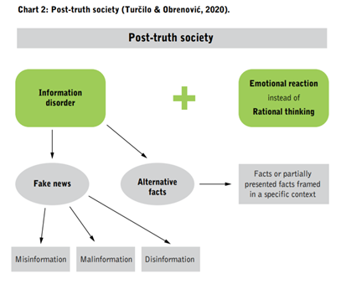
The post-truth society is not only a society in which truth is not a priority; it has almost become its contradiction – a society in which the truth is undesirable, unprofitable, and irrelevant. Fake news and clickbait become the only measure of media success – and this success involves attracting as many people as possible to their site/portal or other media and achieving an emotional reaction to a particular content, which is later emphasized through endless discussions on social networks mainly based on the “explosion” of emotional charge and often hate speech. The 2017 year brings, however, a new phenomenon that is immanent to Trump’s political populism, which is described by the term “alternative facts”, first used by his adviser Kellyanne Conway, saying that, no matter how the media report, the government has “alternative facts”. Alternative facts are not just different facts compared to those transmitted by the media. They are also neither false information nor facts that someone has appropriated for themselves in order to achieve financial and other profits and place them when it suits him. Alternative facts are, in fact, the facts “framed” in a particular context or presented only partially in order to dissuade the public and produce a certain reaction.
Post-truth society is one which is based on the information disorder – either on fake news (misinformation, disinformation, and/or malinformation) or alternative facts (true or partly true information framed in a specific context) – to which the public reacts emotionally rather than rationally.

Answer the questions:
1. What are the characteristics of the post-truth society?
2. What is the role of mis-, dis- and malinformation in the post truth society? Study the chart provided and speak about the interrelation of the mentioned components.
3. What are alternative facts? Do you think this term is appropriate?
4. If fake news and clickbait become the only measure of media success, can media consumeres influence this and change the media landscape? If so, what can and should they do?
5. What is the role of emotions in the process on transmitting information?
THINK. Is “post-truth society” a global phenomenon? Could Ukraine be called a “post-truth” country? Provide your arguments.

PART 5. PRACTICAL TOOLS.

Ex. …. Follow the link: https://www.whichfaceisreal.com/results.php?r=1&p=0&i1=29914.jpeg&i2=image-2019-02-18_172305.jpeg to check whether you are able to distinguish the original photos from the fake ones.

Ex. …. Brainstorm the technical devices that can help create fake photos or videos. Think of the reasons for which they can be created? Are they positive or negative? Why?

Ex. …. Study the definition of the notion “deepfake”.
“The term deepfake is typically used to refer to a video that has been edited using an algorithm to replace the person in the original video with someone else (especially a public figure) in a way that makes the video look authentic.” Merriam-Webster https://www.merriam-webster.com/words-at-play/deepfake-slang-definition-examples

Ex. …. Have you ever seen any deepfakes. What were they? Where were they spread? What was the purpose of their creation and sharing?

Ex. …. Watch a video “How deepfakes undermine truth and threaten democracy” (https://www.ted.com/talks/danielle_citron_how_deepfakes_undermine_truth_and_threaten_democracy) by Danielle Citron. Note the mentioned negative consequences which can be led to by deepfakes implementation.

Ex. …. Google the fake videos and photos created to service in the hybrid warfare in the East of Ukraine. What were they aimed at? How can one know that it is a fake?

PART 6. FURTHER EDUCATIONAL RESOURCES
1. How does YouTube combat misinformation? https://www.youtube.com/howyoutubeworks/our-commitments/fighting-misinformation/
2. Facebook’s new tool to stop fake news is a game changer—if the company would only use it https://fortune.com/2020/10/18/facebook-tool-stop-fake-news-viral-content-review-system-fb-business-model/
3. What Facebook Is Doing to Combat Fake News https://www.scientificamerican.com/article/pogue-what-facebook-is-doing-to-combat-fake-news/
4. Are we living in a post-truth era? Yes, but that’s because we’re a post-truth species. https://ideas.ted.com/are-we-living-in-a-post-truth-era-yes-but-thats-because-were-a-post-truth-species/

PART 7. REFLECTION
1. What do I already know about media and information literacy?
2. What did I learn in this seminar? What was new information to me?
3. What am I planning to do with the new knowledge I have attained during the seminar? How will I implement it in my work right now and in the future? Is it relevant to my field of studies and useful in my daily media habits?
4. How will I continue learning on the topic of media and information literacy work after the seminar?

