MEDIA LITERACY WORLDWIDE

Content:
- know country- and region-specific approaches and terminology ;
-develop a coherent understanding of the basic notions of information and media literacy.
Language:
-provide one’s own analysis of terminology in the field in the written and oral forms;
-present reports on elements of media competencies in global contexts.
Critical thinking:
- activate prior knowledge and systematize facts;
- analyze the current developments of the information and media literacy trends.

PART 1. ACTIVATING PRIOR KNOWLEDGE

Ex.1. Look at the logos of various projects on media literacy. What might be the goals of these projects? What information can you get from the logos? Work in groups and discuss your ideas.

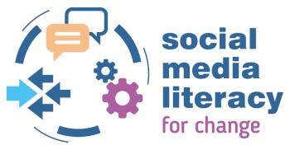 | 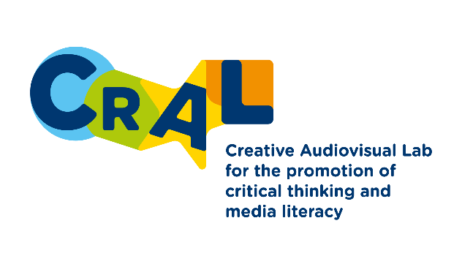
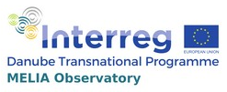 | 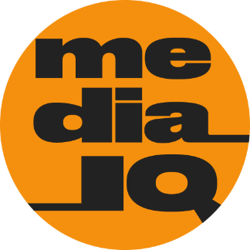
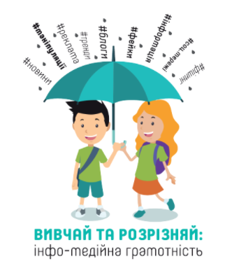 | 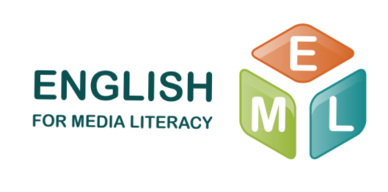

PART 2. PROVIDING AND ENCOURAGING OUTPUT

Ex. 2. Read the summaries of the five projects on media literacy and fill in the table below.

Journalistes en classe – Journalists in classrooms
Eighteen years ago, AJP (Association des journalistes professionnels), France launched an innovative media literacy initiative in Europe that offers to teachers the opportunity to invite a journalist into their classroom.
Before (and also after) the visit in the classroom, the teacher can plan activities focused around media education. Questions to the journalist can be prepared with the students, articles can be written, video sequences can be produced, etc.
This project runs throughout the academic year so teachers can choose when they want to invite a journalist in the classroom. AJP also produces educational resources for the journalists, the teachers, and the students.

Children, teachers and parents against hate speech and discrimination
Children are exposed to hate speech from a very young age, due to their early entry into the digital world. Their encounter with a constant and normalized use of hate speech in the Internet comes at a time when they do not yet possess moral and psychological barriers towards the manifestation of ethnical, religious or gender-based discrimination. The project “Children, teachers and parents against hate speech and discrimination”, carried out in two main stages, aims to counteract this tendency.
The first stage of the project implemented by the Bulgarian Centre for Safer Internet (SIC) has been devoted to the selection and development of 10 lesson plans for pupils at primary school. The developed methodology is also relevant to parents and teachers. The lesson plans have foreseen different extracurricular activities with joint participation of children, parents and teachers. In this way, parents can actively support the development of new skills of their children.
In the second stage of the project, the finalized lesson plans have been tested in four schools in Sofia (two of which have students from different ethnic backgrounds). The testing has provided valuable feedback utilized for the elaboration of relevant methodological guidelines to be presented to teachers in different primary schools.

Children and Media
In 2011, the Council for Radio and Television Broadcasting121 (media regulatory authority) launched the website “Children and Media” (www.deti-a-media.cz) to serve as a platform for presenting and exchanging experts’ opinions and as an information source for parents, teachers and other educators who are interested in negative influence that media can have on their children.
The website is intended to educate and inform parents about issues related to television law and its risks to children, and children’s TV use. Although the title of the website suggests the focus is on media in general, the content of the web is primarily related to television. It consists of several educational sections where the basic terms are explained and FAQs are answered.

So you got naked online?
The material is made in collaboration between the Safer Internet Centre Denmark (SIC DK), consisting of Centre for Digital Youth Care, Save the Children Denmark, and the Media Council for Children and Young People. The material consists of a small printed booklet, “So you got naked online?”, and a more extensive online version.
The booklet “So you got naked online?” aims to empower young people in situations where their images have been shared without their consent. The booklet provides young people with knowledge about images online and provides them with practical guidance on what to do, who to contact and how to minimise damage in a situation of unwanted sharing of images or films. At the same time, the booklet has a preventative aim, as it has been distributed through schoolteachers and local SSP (partnership between schools, police and social service with focus on prevention of youth crime).

Practical training workshops by Young People’s Media Club
Young People’s Media Club, NGO (Noorte Meediaklubi) is a network that consists of approximately 70 young professionals (mostly new journalists and students of journalism and communication from the University of Tartu, but also from the Baltic Media School of the Tallinn University). All of the members have personal experience of working for the school radio or for the school newspaper.
This younger generation of established journalists and media and communication specialists are aiming to raise awareness and teach practical skills and knowledge around media literacy to secondary and high school students around Estonia.
The activity of NMK is designed to enhance practical journalistic skills of students and develop their media literacies as well as growing their interest in media-related matters. Many participants of the training courses have initiated or been part of various school media projects in their respective high schools e.g. launching school newspapers, school radio, or TV shows.

Table

Title/country | Target Audience | Stakeholders | Activities
 |  | teachers, journalists, students, parents
 | children, teachers, parents
Children and Media/
 |  |  | preparing a booklet
/Estonia

PART 3. READING

Ex. 3. Read the article highlighting the importance and the outcomes of projects on media literacy.

MEDIA LITERACY: DEFEATING DISINFORMATION THROUGH EDUCATION – UKRAINE ON THE GLOBAL FAKE NEWS FRONTLINES

Mehri Druckman, 12 August 2018

Since 2014, disinformation has played a key role in Russia’s hybrid attack on Ukraine. Ukrainian audiences are now a key battleground in the international fight to improve media literacy and defend against the dangers of fake news
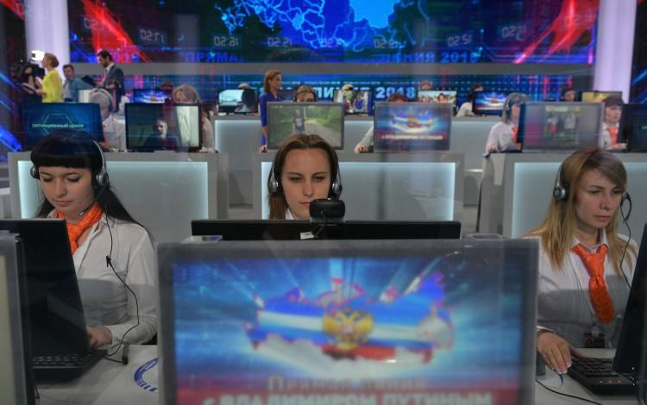
Countering Kremlin TV: the Russian media is a key source of fake news in Ukraine but efforts are underway to improve media literacy among Ukrainian audiences and reduce the threat posed by Moscow’s multimedia disinformation campaigns

Long before “fake news” became a household term around the world, Ukraine found itself in late 2013 on the frontlines of a complex multi-layered disinformation war. Although propaganda has existed for centuries, it has never before been delivered with the same speed, sophistication and reach as it does in today’s technologically interconnected multimedia world. As Vassily Gatov, a researcher of Russian media rightfully noted: “If the greatest battle of the twentieth century was the battle for freedom of information against censorship, then the greatest battle in the twenty-first century will concern the abuse of freedom of information and the use of information as a weapon by authoritarian rulers and aggressive non-state actors.”

Beyond Debunking
In this battle, solutions addressing both the “supply” side and the “demand” side are necessary. This means ensuring a vibrant and independent media environment while also educating citizens to consume information critically. Too often, efforts to counter disinformation tend to focus exclusively on the supply side. Independent media that debunk myths, create fact-based content, and conduct investigative reporting play an essential role in the broader struggle but they cannot win this battle alone. Citizens need to learn how to value good content and they need to know how to identify it within the flood of information constantly flowing at them. This requires the ability to distinguish between fact and fiction.
Global education systems have not evolved at the same speed as technology, leaving citizens poorly equipped to navigate through the diversified new media space we find ourselves in today. At the same time, most people like to think they cannot be manipulated. Sadly, the available evidence suggests this confidence is misplaced. According to Pew Research Center, 23% of US adults have shared a made-up story, knowingly or unknowingly. With the advent of the internet and social media, individual citizens are now “news” outlets themselves, underscoring the importance of training citizens on media literacy techniques so they do not spread false information.

Empowering Audiences
To address this critical issue and with funding support from Canada, IREX created “Learn to Discern”, a media literacy project designed to equip citizens with the skills to distinguish fact from fiction and empower them to make up their own minds about important issues without being manipulated. Traditional approaches to teaching media literacy skills have not evolved with the rapidly changing information space. Today’s media landscape includes disinformation of increasing sophistication. It is often colorful, emotionally charged, and slickly packaged in different formats. Together with our partners at the Academy of Ukrainian Press and StopFake, we set out to create a new media literacy curriculum to address these challenges and provide very practical skills that change how people consume media and absorb information in their daily lives. The objective of the Learn to Discern initiative is not to tell people what to read or watch, but rather to teach them how to consume information wisely. It is all about introducing healthy media consumption habits, so that the next time participants have a strong emotional reaction to something they read, they will pause before pressing the “share” button and ask themselves: who is benefiting from this and who wants me to have this level of emotional reaction?
Learn to Discern’s methodology encourages critical self-reflection and behavior changes, not simply academic exercises to dissect news articles. It takes into account three critical factors that influence how people consume information today. Firstly, avoiding emotional manipulation. In the Internet age, emotional manipulation through media has significantly worsened. Gone are the days of easily verifiable media ownership when a few professional outlets produced content. Today’s market is clogged with chatbots, trolls and online memes that are designed to create confusion, chaos and scandal. IREX has found that most available media literacy courses, by and large, fail to address this evolution and are not properly equipping citizens with techniques for recognizing their own emotional reactions so that they can read and consume news more critically.
Secondly, we set out to teach audiences how to watch rather than what to watch. Consumers now pick the format of media such a TV, radio, podcasts and social media that best fits their lifestyle. It is virtually impossible to encourage people to restrict their information consumption to specific news sources known to be more credible. At the same time, because of the cognitive shortcuts we all use such as confirmation bias, people choose news based on what supports their preexisting opinions and values. Therefore, media literacy training cannot realistically hope to tell people what to consume, but it can train them on how to consume regardless of what type of media people chose.
The third key objective is to adapt to diverse media consumption habits. Different segments of audiences get their information in very different ways. Some listen to the radio, some watch TV, some get news through social media and podcasts. How disinformation manifests itself looks different in each of these formats, so media literacy training must be tailored to different groups of people or it simply will not be relevant to an individual’s media consumption habits.

Ukrainian Outreach
Over a nine-month period, we trained over 15,000 people in 14 eastern, southern and central regions of Ukraine. The Learn to Discern initiative reached people of all ages, genders, and professional backgrounds through peer networks. Ninety-one percent of those who underwent training reported sharing their media literacy skills with an average of six friends, relatives or colleagues, expanding the training’s indirect impact to 90,000 people.
Person training was complemented by a Learn to Discern video game and distance learning course to ensure that the project reached an even wider range of audiences. At the same time, IREX launched a public service announcement calling for responsible, deliberative information consumption while drawing an analogy to checking the ingredients on a nutritional label when we purchase food, which reached 20.7 million people.
In late fall of 2017, 18 months after the project ended in Ukraine, we evaluated the long-term impact of the program using a stratified random sample of 200 participants and comparing the results to a 200-person control group matched for gender, age, region, and education level. The results showed that Learn to Discern participants had statistically significant higher levels of disinformation analysis skills, greater knowledge of the news media environment, and a stronger sense of agency over the media sources they consumed. Importantly, they were also more likely to consult a wider range of news sources. Compared to the control group, L2D participants were 28% more likely to demonstrate sophisticated knowledge of the news media industry, 25% more likely to self-report checking multiple news sources, and 13% more likely to correctly identify and critically analyze a fake news story.
Currently IREX is adapting the Learn to Discern methodology for use in other countries around the world that are at high risk of disinformation tactics. In Ukraine, with the support of the embassies of the United States and United Kingdom, IREX is now integrating the Learn to Discern methodology into 50 schools in the cities of Ternopil, Chernihiv, Mariupol and Dnipro so that the next generation of Ukrainians is better equipped with skills to avoid becoming victims of disinformation manipulation.

http://bunews.com.ua/society/item/media-literacy-defeating-disinformation-through-education-ukrainian-audiences-on-the-global-fake-news-frontlines

Ex. 4. Answer the questions:

1. What role does disinformation play in the modern world? Why?
2. Why is educating citizens to consume information critically important in Ukraine and globally?
3. What is the “Learn to Discern” project aiming at? Why is it important for Ukraine?
4. What are the methods and techniques IREX used in its project on media literacy? What would work better for young people in your opinion?
5. What is the short-term and long-term impact of the project on media literacy?

Ex. 5. Work individually. Make a list of 5 questions you might ask Mehri Druhman about the project “Learn to Discern”. Compare your questions with other students in small groups or in pairs.

PART 4. GUIDING TO MORE CALP

Ex. 6 a. Do you think it’s possible to measure media literacy in a society? Have you ever heard about the media literacy index? Look at the charts below representing the media literacy index of Ukrainians and discuss your findings in groups of 3-4.

Ex. 6 b. Work in groups of 3-4. Find more information about the media literacy index of Ukrainians. Use Google search to answer the questions about the organizations responsible for its conducting, its frequency and dynamics.

Media Literacy Index

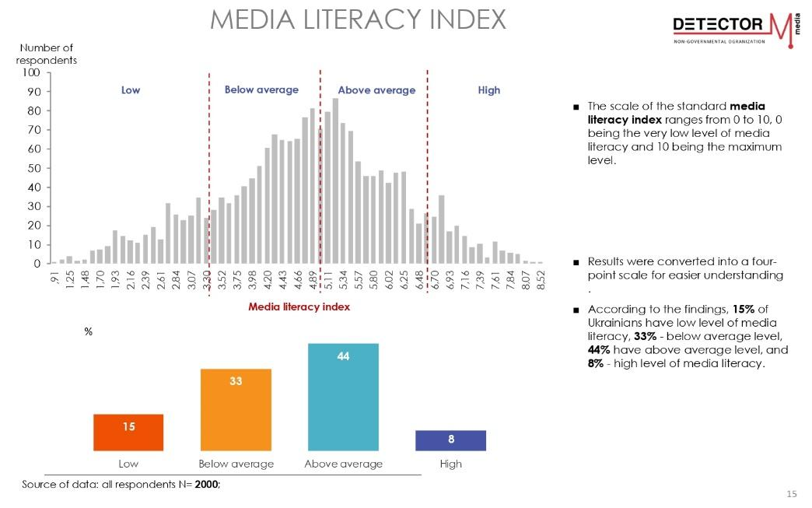

Ex. 7. Work with the clusters of Media Literacy Index of the European countries, read the information about the project and study the table.

The Media Literacy Index was created in 2017 as a response to the ‘post-truth’ phenomenon11 to measure the potential for resilience to ‘post-truth’, ‘fake-news’ and their consequence in a number of European countries and contribute to finding solutions. The Media Literacy Index 2021, presented in this report, is the fourth edition of the index after those in 201712, 201813 and 201914. The Media Literacy Index scores and ranks 35 countries in Europe according to their capacity to withstand the ‘post-truth’ and its negative ramification. The main assumption is that indicators for media freedom, quality of education, interpersonal trust and e-participation can serve as predictors to the level of resilience of a society to fake news, post-truth and related phenomenon. The concept of media literacy is employed to gauge the potential for resilience to the negative effects of diminishing public trust, severely polarized politics, and fragmented media, among others.
The clusters are groups of countries with similar characteristics along the line of the Media Literacy Index 2021. The clusters are also hierarchical – from the top performers in the first cluster to the last in the fifth cluster. The first cluster is composed of a small group of six countries from Finland to the Netherlands, which are the best performers in index 2021. The second cluster is the biggest one with 11 out of 35 countries, starting with Belgium (7th place with 64 points) to Poland (17th place with 56 points). The third cluster is composed of 9 countries out of 35 in total from Lithuania (18th with 53 points) to Hungary (25th with 42 points) and Cyprus (26th with 42 points). The fourth cluster is composed of six countries – from Greece (27th place with 38 points) to Montenegro (32nd with 26 points). The fifth and last cluster is the smallest one, comprised of three countries – Albania (33rd with 22 points), BiH (34th with 19 points) and North Macedonia (35th place with 15 points).

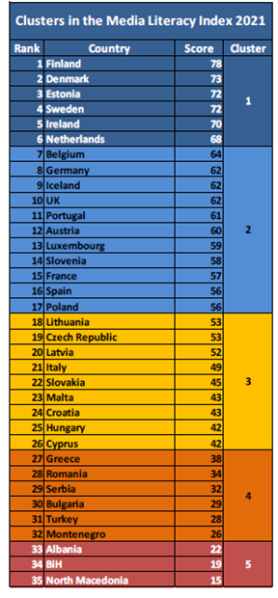 | Answer the questions.  1. Analyze the clusters of countries. What conclusions can you make about this hierarchy?  2. What may be the difference about everyday media habits of the top and bottom countries of the rank?  3. Where might Ukraine be placed in this rank? Why so?

PART 5. WRITING - VLOG

Ex. 8. Work in groups and write your own project aiming at fostering Media Literacy in your community. Follow the template.

Template

Title of the project

Terms of the project implementation

Coordinator of the project

Team of the project

Previous relevant experience of the team members

Aim of the project

Target audience of the project

Why is this project important for your target audience? (up to 100 words)

Description of the project (up to 300 words)

Expected outcomes of the project

Partnership needed (if any)

Finances needed (explain what for)

Ex. 9. Make a short video (3 min max) presenting the project aiming at fostering Media Literacy in your community.

Ex. 10. Ask students to make a presentation of their project in the class. Students listen to presentations of their peers carefully and ask questions about the projects, clarifying its aims, expected outcomes and other components. Pay attention to the sustainability of the project and its importance for the community.

PART 6. FURTHER EDUCATIONAL RESOURCES

- U.S. Media Literacy Policy Report 2020 https://medialiteracynow.org/u-s-media-literacy-policy-report-2020/
- Media Literacy Index 2021 https://osis.bg/?p=3750&lang=en
- The evolution of journalism and media literacy in Ukraine https://www.youtube.com/watch?v=V1z8SfniQrM

PART 7. REFLECTION
1. What do I already know about media and information literacy?
2. What did I learn in this seminar? What was new information to me?
3. What am I planning to do with the new knowledge I have attained during the seminar? How will I implement it in my work right now and in the future? Is it relevant to my field of studies?
4. How will I continue learning on the topic of media and information literacy work after the seminar?

